 

Database Systems

 Al-Fareed Clinic Management System

Prepared By:

*Team: Cup of Tea*

Ayesha Siddiqa 241419 Muhammad Ali 241383

Email: 241419@students.au.edu.pk Email: 241383@students.au.edu.pk

Department of Creative Technologies Department of Creative Technologies

Marium Wajahat 241936 Muhammad Zain ul Abideen 241475

Email: 241419@students.au.edu.pk Email: 241383@students.au.edu.pk

Department of Computer Science Department of Creative Technologies

Submitted To

Sir Danish

Email: uswah.ahmad@students.au.edu.pk

ABSTRACT

This project is developed to solve the problems faced by a **local clinic in Fort Abbas**, where all operations are currently managed manually. Due to lack of a proper system clinic faces **record, scheduling, billing, and inventory issues**.The **Clinic Management System** aims to **digitize these processes** by introducing a **computer-based platform** that will help the clinic manage **appointments, patient records, billing, pharmacy inventory, and administrative tasks** in a better way . It will include different panels for **Admin, Doctor, Receptionist, and Pharmacist**, so that each staff member can perform their duties without confusion. The system will also generate reports to help admin with decision-making and improving patient care.

This system will be built using **C# and the ASP.Net framework**. A **Hybrid approach** will be used for development, combining **structured planning with flexible updates**. The project will be completed in **different stages**, focusing on one part at a time to make sure everything works smoothly.

Table of Contents

1. Introduction 6

1.1 Purpose 6

1.2 Motivation 6

1.3 Project Title 7

1.4 About Al-Fareed 7

2. System Overview and Problem Description 7

2.1 Existing Problems 7

2.2 Proposed Solution 8

3. Project Scope and Objectives 9

3.1 Scope of Initial Release 9

3.2 Scope of Subsequent Releases 9

4. Stakeholders 9

5. Requirements 10

5.1 Functional Requirement 10

5.2 Non-Functional Requirement 11

5.3 Hardware Specification 12

6. Project Timeline 12

7. Use Case Diagrams and System Workflow 14

7.1 Use Case Diagram: 14

7.2 Activity Daigram: 15

7.3 Entity Relationship diagram(ERD) : 16

7.4 Schema 16

7.5 Graphical User Interface Design 17

7.6 Frontend 19

7.6.1 WelLogin/Signup 19

7.6.2 Admin: 22

7.6.3 Doctor: 23

7.6.4 Receptionist: 26

8. Conclusion 27

9. References 27

9.1 Diagrams & External Resources Used 27

9.2 Bibliography: 28

Main Objectives of this Document are :

* **System Overview**
* **Scope**
* **Requirements**
* **Front end**
* **ERD**
* Schema
* Demo Video

# Introduction

Al Fareed Clinic in Fort Abbas has been managing its operations manually, which has led to inefficiencies in record-keeping, appointment scheduling, and financial management. To improve their workflow, this system aims to automate certain tasks while digitizing others, ensuring that their daily operations become more organized and efficient. By reducing manual effort, the system will help the clinic digitize its processes, making it easier to manage patient records, financial reports, and staff performance

## Purpose

The purpose of this system is to assist Al Fareed Clinic in shifting from a manual process to a digital one, making their management tasks easier and more efficient. The system will store patient records, automate appointment scheduling, track financial data, and monitor staff performance. By implementing this system, the clinic can improve its efficiency, reduce errors, and enhance the overall patient experience.

## Motivation

Managing a clinic manually can be time-consuming and prone to errors, especially when handling patient records, finances, and staff performance tracking. Al Fareed Clinic has faced challenges in organizing its data effectively, which can lead to misplaced records, difficulty in financial tracking, and inefficiencies in scheduling appointments. This system is designed to solve these problems by introducing automation where needed and computerizing essential tasks, ensuring that clinic operations become smoother and more manageable.

## Project Title

*“Al-Fareed Clinic Management System”*

## About Al-Fareed

Al-Fareed Clinic is a private healthcare facility located in *Fort Abbas* . It is owned and managed by **Talha** and provides medical services to the local community. The clinic operates with a team of skilled professionals, including :

* *Admin*
* *Pharmacist*
* *Laboratory technician*
* *And Two Doctors—General Physician and Physiotherapist*

# System Overview and Problem Description

Al Fareed Clinic has been relying on manual processes, which has made it difficult to keep track of important records. Without a structured digital system, they face several challenges in managing appointments, finances, and patient histories.

## Existing Problems

The main issues faced by Al Fareed Clinic include:

* Challenges in managing financial records and dividing earnings among stakeholders.
* Inefficiencies in appointment scheduling and keeping everyone aligned
* No structured way to track staff performance, making it hard to measure contributions and improvements.

## Proposed Solution

To address these problems, the new system will provide a structured, computerized solution for Al Fareed Clinic. It will include:

* A digital database for securely storing and accessing patient records.
* An automated appointment scheduling system to streamline bookings and reduce scheduling conflicts. And will keep everyone aligned
* A financial tracking module to keep record of the reports.

|  |  |  |
| --- | --- | --- |
| *Module* | *Problem* | *Solution* |
| Financial Management | Admins struggle to track clinic finances and revenue distribution. | The system will provide financial summaries, equity details, and visual reports. |
| Staff Performance Analysis | No proper way to assess staff efficiency. | The system will track staff performance, helping the admin make better decisions. |
| Appointment Management | Doctors may overlook their schedules | Automated reminders will keep doctors informed about their appointments. |
| Patient Record Management | Doctors waste time by asking patients every time they visit for past details. | A digital record system will allow quick access to patient history. |
| Pharmacy Inventory | Clinics face difficulty in tracking medicine stock. | The system will manage pharmacy inventory and alert staff and admin about low stock levels. |

* A staff performance monitoring system to help in evaluating contributions and improving efficiency.

By implementing this system, the clinic will be able to manage its operations more effectively, reducing workload and improving overall productivity.

# Project Scope and Objectives

The system will be developed in phases, so that features are delivered first, with further improvements based on client feedback

## Scope of Initial Release

The first release of the system will focus on digitizing and automating the most essential tasks for Al Fareed Clinic. This includes:

* Patient record management
* Financial tracking and reporting
* Pharmacy Inventory management

## Scope of Subsequent Releases

Based on feedback and future needs, additional features may be introduced in later versions, such as:

* Appointment management
* Staff performance monitoring
* Additional security measures for better data protection
* Optional integrations to 3rd Parties (i.e Marham) if demanded in the future

# Stakeholders

* *Clinic Owners/Admins :*
* Manage the clinic’s operations overall.
* Keep track of finances, patient visits, and staff performance.
* Controls system access and security settings.
* *Doctors :*
* Check patient history and provide treatment.
* Update medical records and prescriptions.
* Manages appointment schedules.
* *Receptionists:*
* Book, reschedule, and cancel patient appointments.
* Keep patient records organized.
* Assist in communication between doctors, pharmacists, and patients.
* *Pharmacists :*
* Give out medicines based on prescriptions.
* Keep track of medicine stock and update the system.
* Make sure prescriptions are followed correctly.
* *Patients :*
* Get medical treatment from doctors.
* Book their appointments through pharmacist.

# Requirements

## Functional Requirement

There are few of the functional requirements in the system.

1. *Patient Record Management*
   * The receptionist should be able to register new patients and update existing patient records.
   * The system must store patient details, including medical history, prescriptions, and doctor notes.
2. *Queue Management*
   * The receptionist will add patients to the queue based on their check-in time.
   * The system would arrange patients in a *first-come, first-served* manner unless the doctor prioritizes urgent cases.
3. *Appointment Management*
   * The receptionist would schedule, reschedule, or cancel appointments based on patient requests.
   * Automated reminders will notify doctors and receptionists about upcoming appointments.
4. *Pharmacy Inventory Management*
   * The pharmacist would update stock levels and receive alerts when medicines are running low.
   * The system would allow pharmacist to search for medicines and alternatives according to formula if a required medicine is unavailable.
5. *Financial Management*
   * The system would track clinic revenue, expenses, and financial records.
6. *Staff Performance Tracking*
   * The system would monitor staff performance and generate reports for administrative review.

## Non-Functional Requirement

Since the system is used in a clinic, it is a must to ensure that everything is doing well especially performance during the working hours. Few non-functional requirements are found and listed below:

* Usability

The system must fulfill its’ own objectives. All the modules and functions of the system should be usable. It is important to ensure that every function is meaningful to the system. And The system should be user-friendly so that receptionists and other staff can navigate it easily.

* Responsiveness

The system must responds every requests from the user in very few seconds in order to decrease the waiting time of the patient as well as doctor and nurse. Responsiveness is one of main concern during the system implementation.

* Reliability

The system should be reliable at least 99% of the time to avoid clinical disruptions

* Security

Only authorized staff should have access to patient data.

Patient records and financial data must be encrypted to ensure confidentiality

* Scalability

The system should handle an increasing number of patients, appointments, and inventory records without performance issues.

## Hardware Specification

Minimum hardware requirements for this system would be :

* *Operating System:* Windows XP, Windows 7 or above
* *Processor:* Intel Core 2 Duo Processor
* *RAM:* 2GB or above
* *Disk Space:* 100GB or above
* *Internet Connection:* At least 1Mbps

# Project Timeline

🔹 Mar 28 - Apr 6: Database schema design (Tables, relationships, constraints) +Front end

🔹 Apr 7 - Apr 11: SQL Server setup and testing basic CRUD operations

🔹 Apr 12 - Apr 18: Backend development (Authentication, Patient & Doctor Management)

🔹 Apr 19 - Apr 25: Backend integration with frontend (WinForms + SQL Server)

🔹 Apr 26 - May 3: Implement Appointment & Prescription modules

🔹 May 4 - May 10: Implement Billing & Inventory management

🔹 May 11 - May 15: Develop reporting & admin dashboard

🔹 May 16 - May 20: Real-time graphs & data visualization (SQL Server)

🔹 May 21 - May 27: Unit testing (Database, backend, and UI interactions)

🔹 May 28 - June 3: Debugging, bug fixes, and performance optimization

🔹 June 4 - June 7: Prepare final documentation user manual

🔹 June 8 - June 10: Final system review & practice presentation

# Use Case Diagrams and System Workflow

## Use Case Diagram:

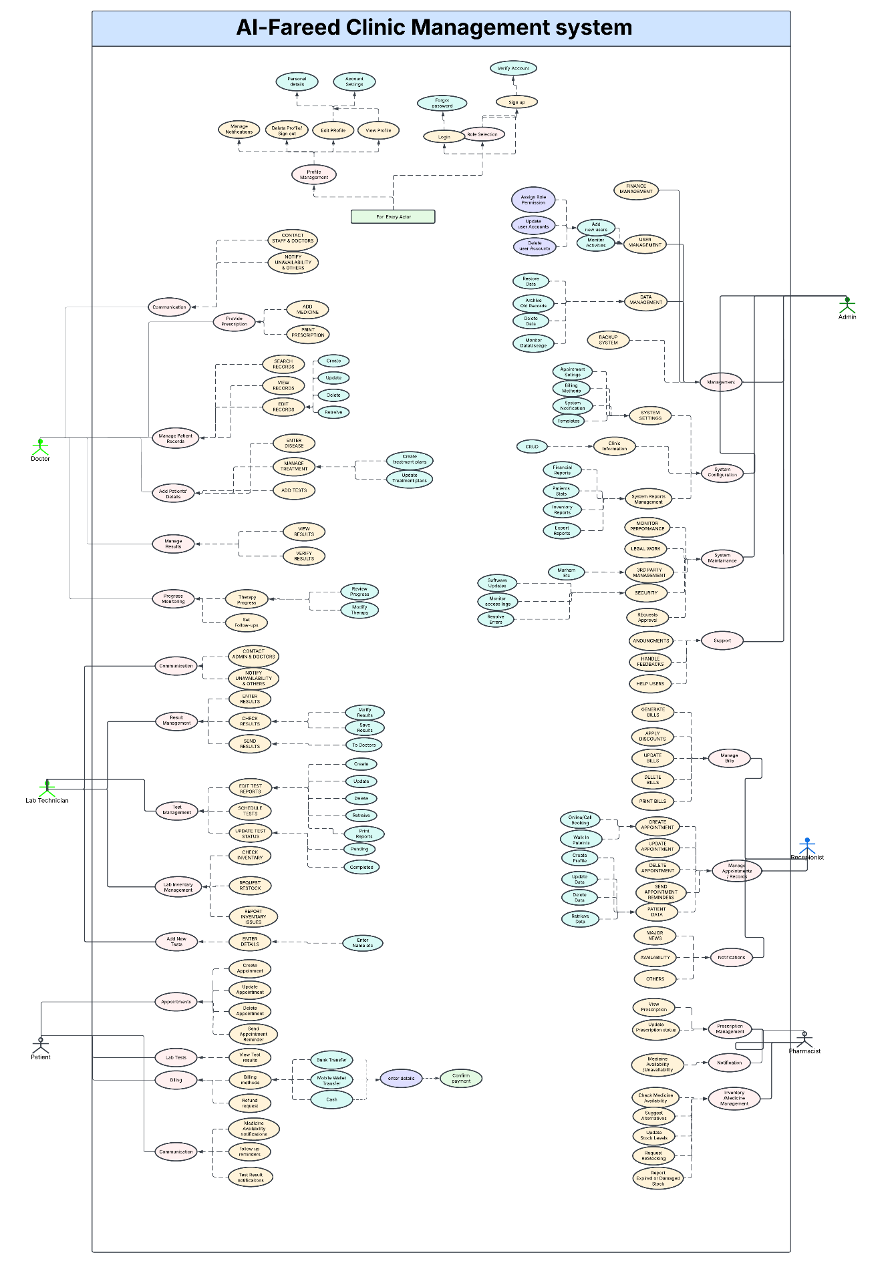

For better clarity, the detailed use case diagram can also be viewed at the following Lucid charts link[1]

## Activity Daigram:

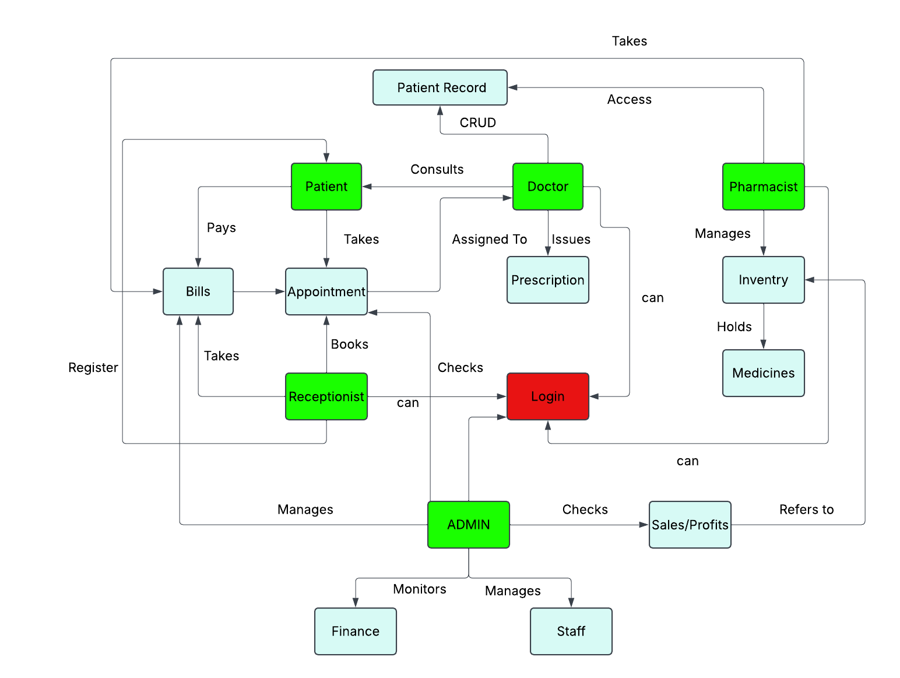

For better clarity, the activity diagram can also be viewed at the following Lucid charts link [2]

## Entity Relationship diagram(ERD) :

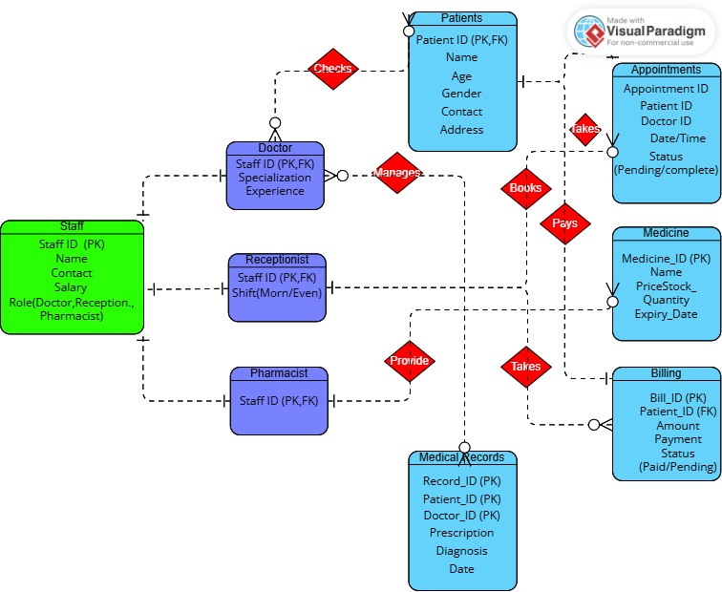

## Schema

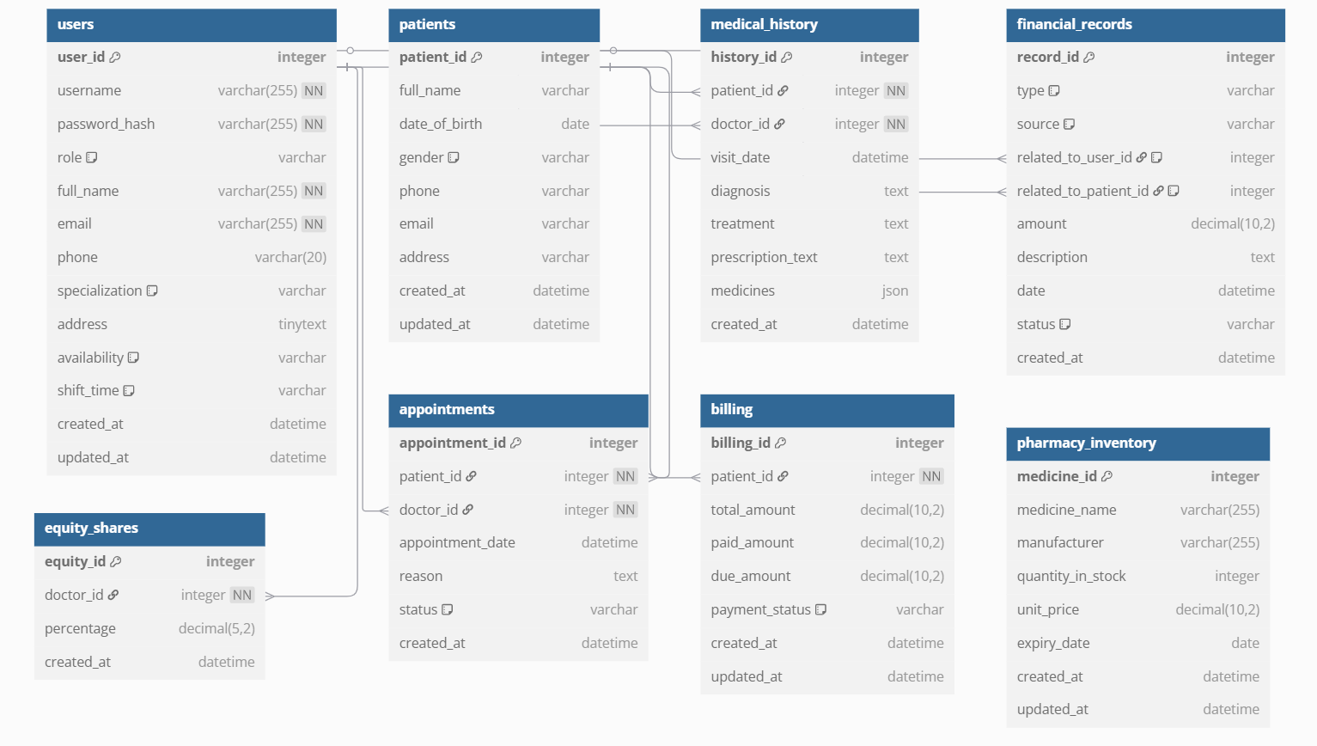

And For better clarity, the activity diagram can also be viewed at the following dbdaigram.io link [4]

## Graphical User Interface Design

In this system, since it is an internal system, therefore it is being design in a very simple layout. The system is using three shades of green with codes

***#55AD9B***

***#95D2B3***

***#D8EFD3***

and white with code #FFFFFF in the design since it gives clearer layout to the people as pharmacist , receptionist and doctor need to face the screen for the whole long working hours.



Figure 4-1 Splash Screen

Figure 4-2 Logo Design

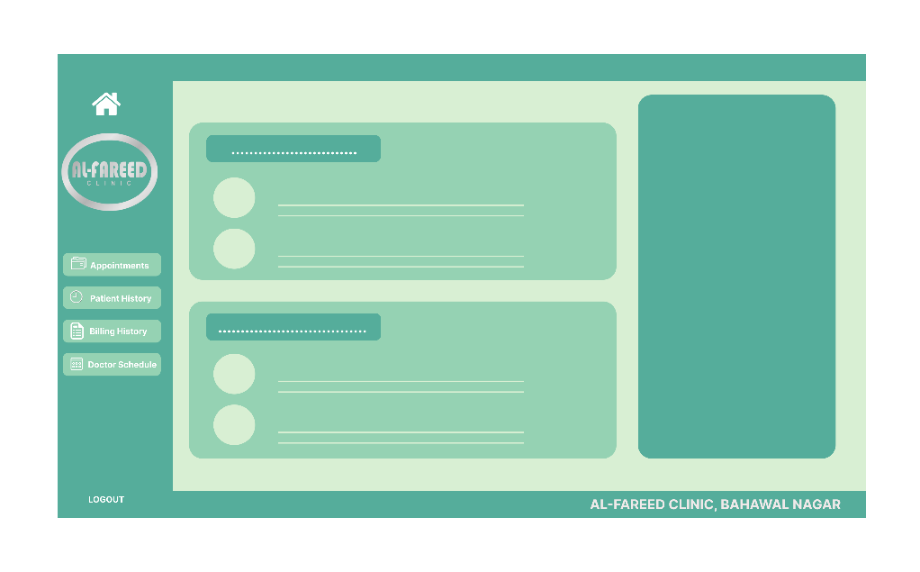

Figure 4-3 Basic Layout Design

User Interface: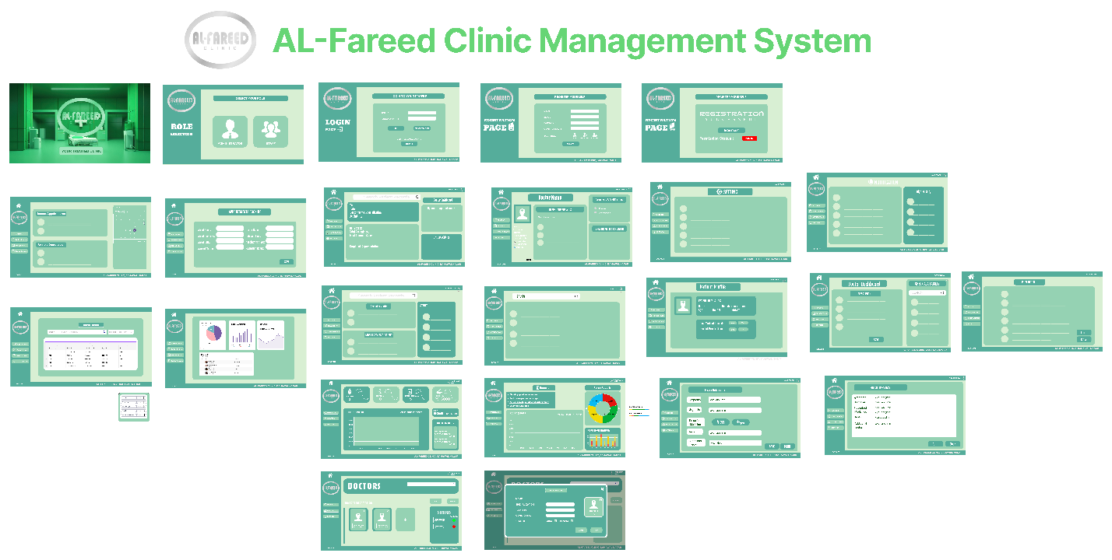 you can also check out in figma through this link [3]

## Frontend

As we have already metnioned that we have 4 stakeholders and we have providede a separate interface to each one of them

So here is the front end of AL-Fareed-Clinic Management System separated accordingly:

And For better clarity, the activity diagram can also be viewed at the following dbdaigram.io link [4]

### WelLogin/Signup

This is the first splash screen

Then comes User Registration Screen where User will Register himself

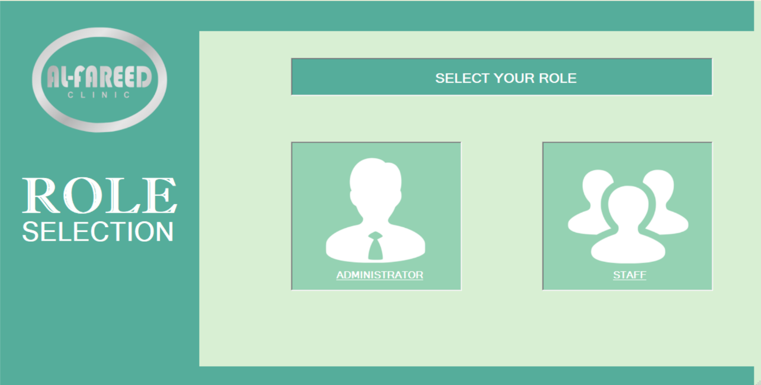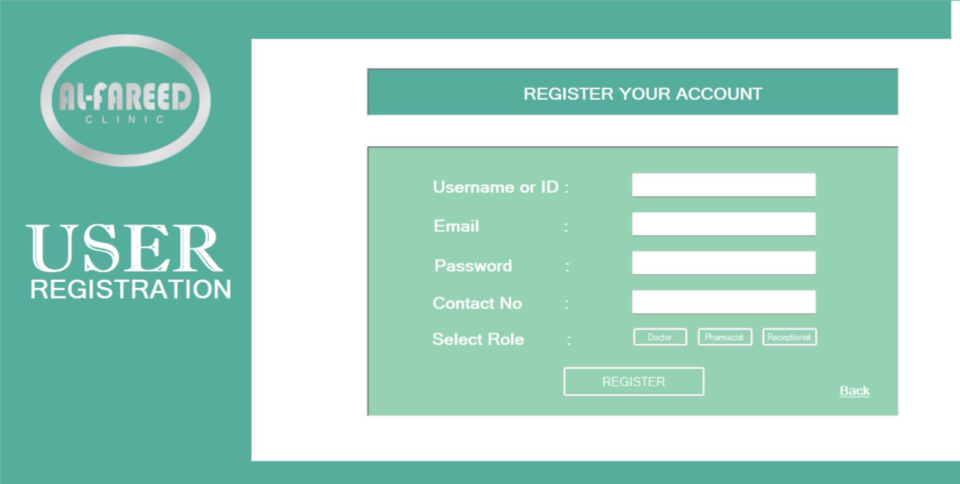

then He will send it tot the admin for Confimation and will wait till Admin Confirms it

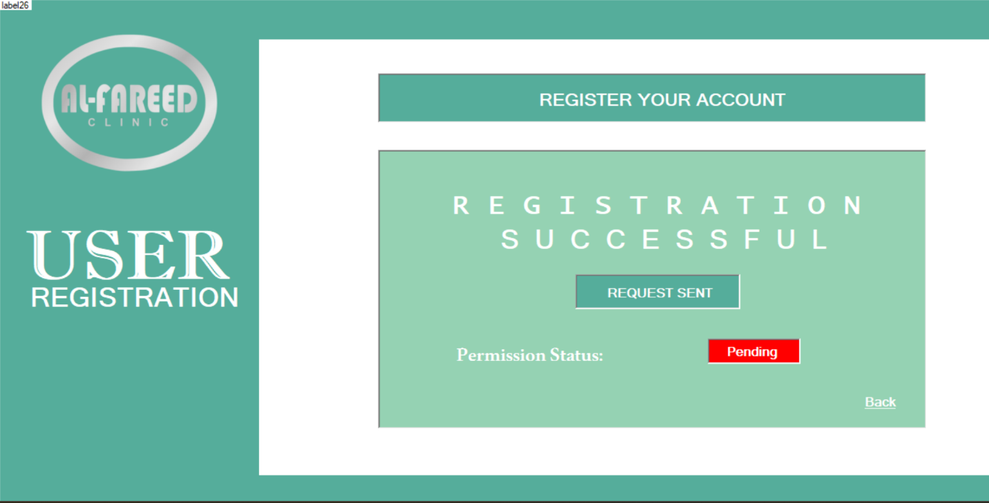

After that He would be able to login through his credentails

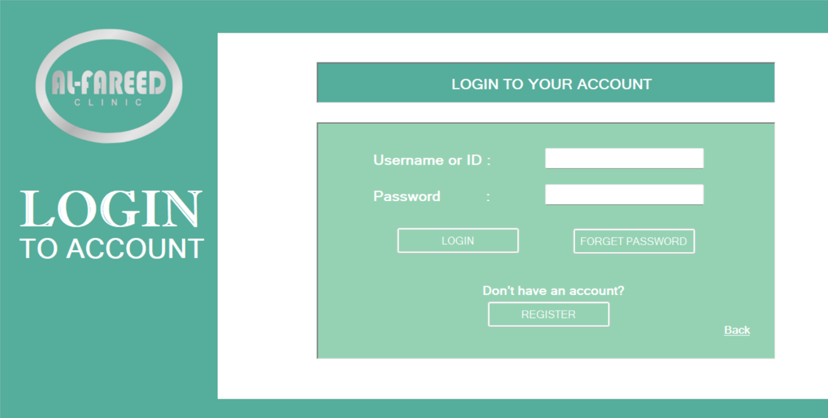

### Admin:

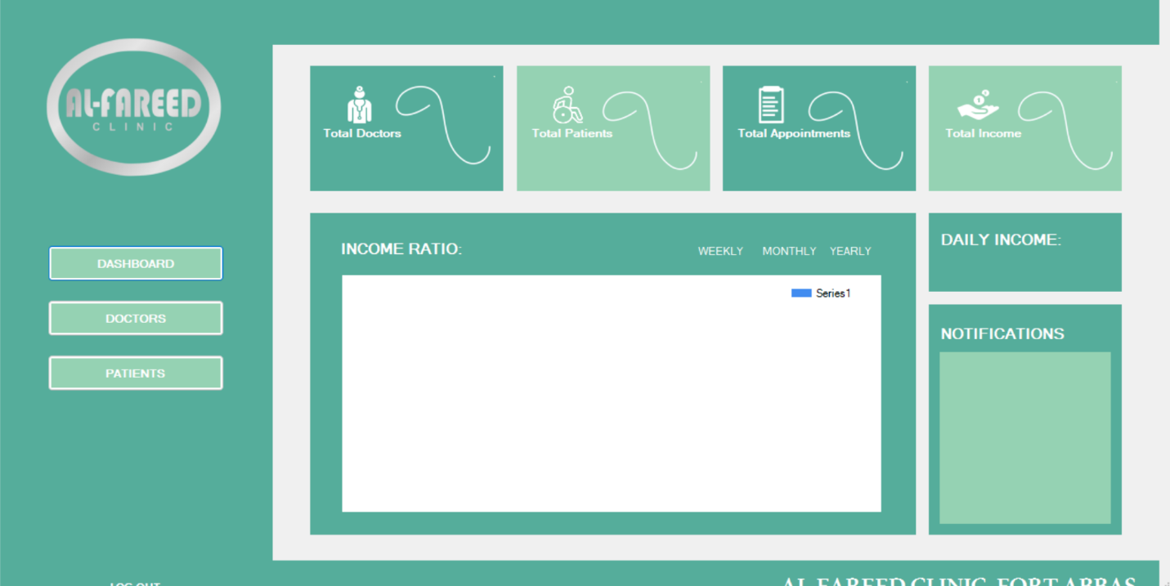

Here is the main dashboard of the Admin where he can see all of the stats and updates

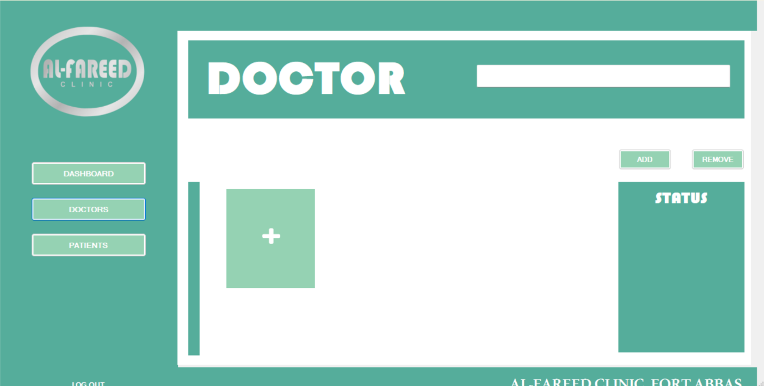

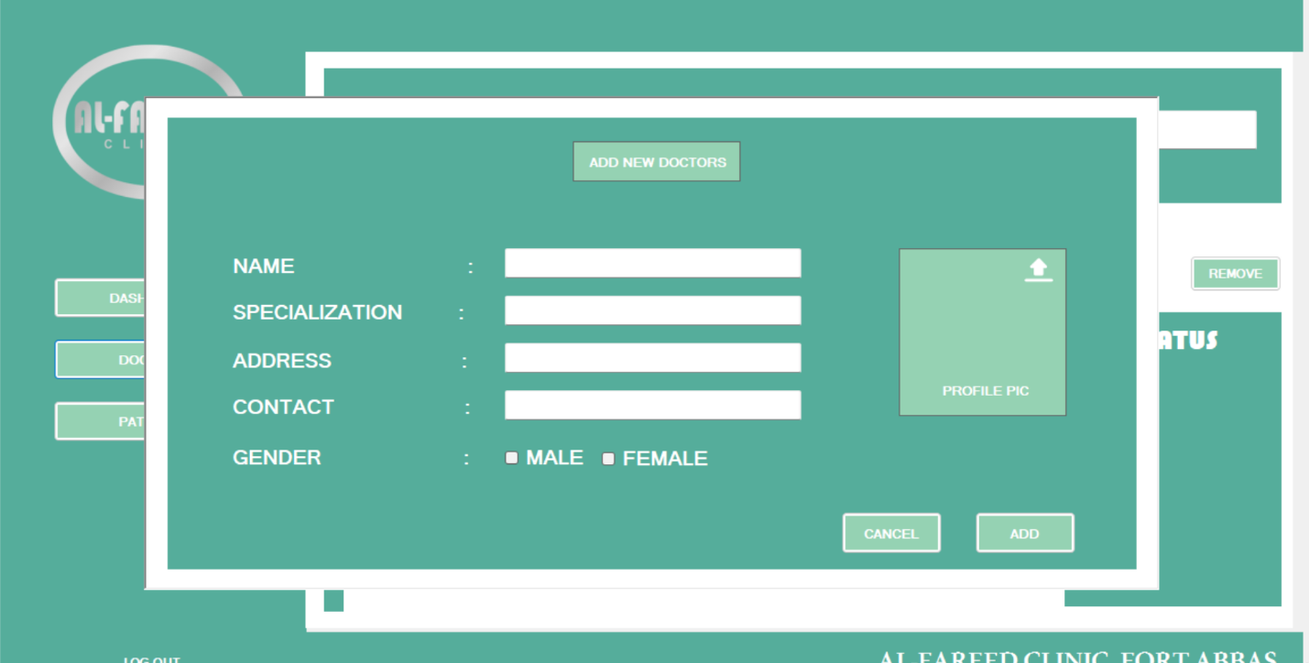

These two panels would be used to add New staff members

### Doctor:

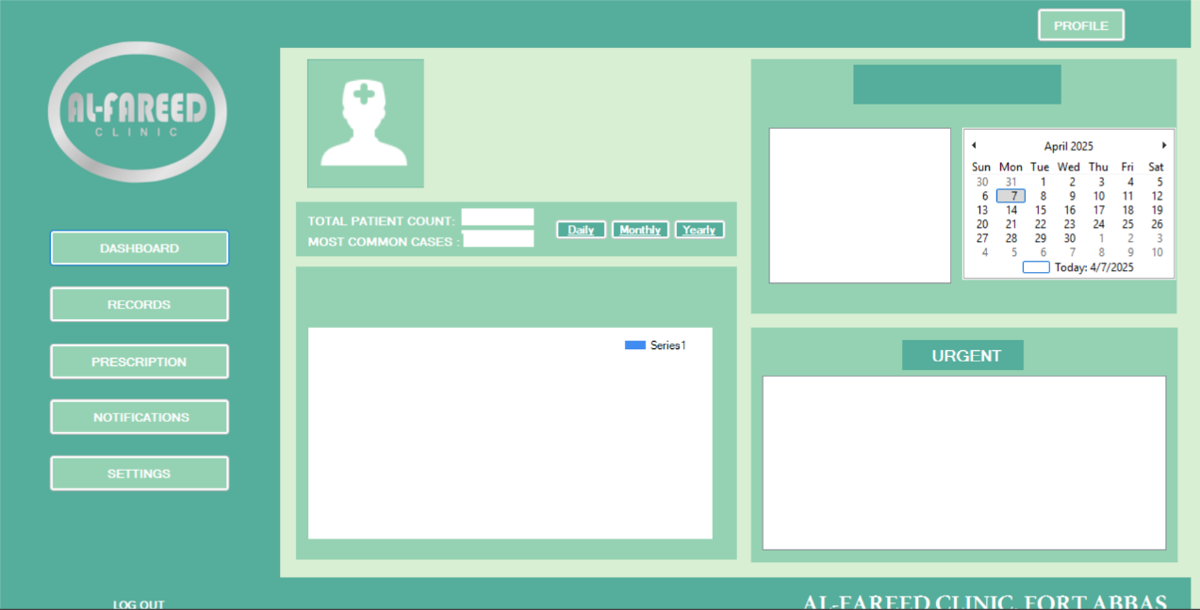

This is doctor’s main dashboard

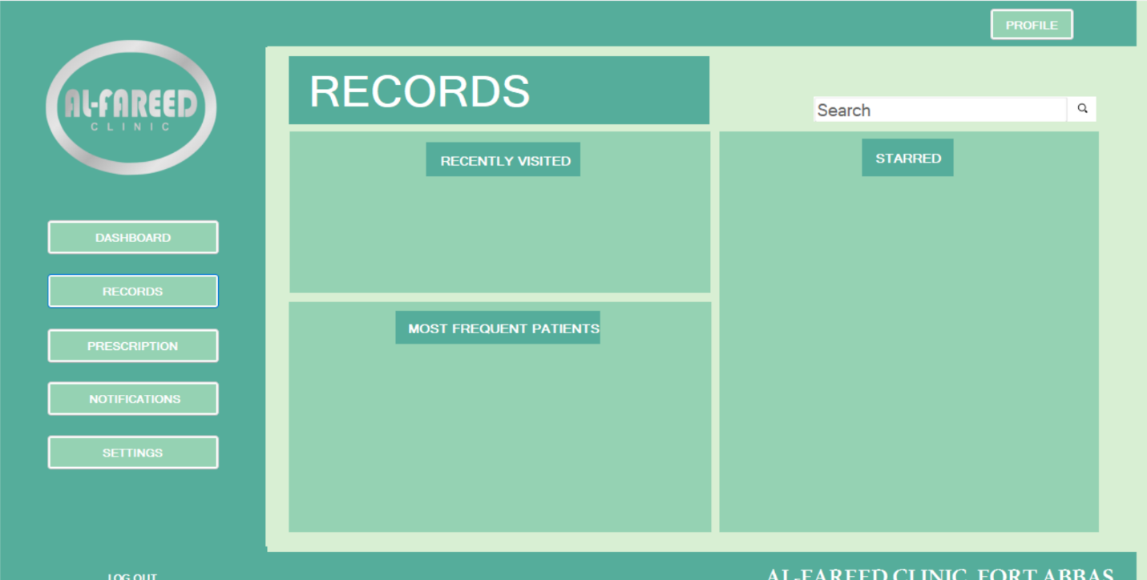

This one is Records Explorer , from where doctor can search and visualize all of the medical histories of his patients

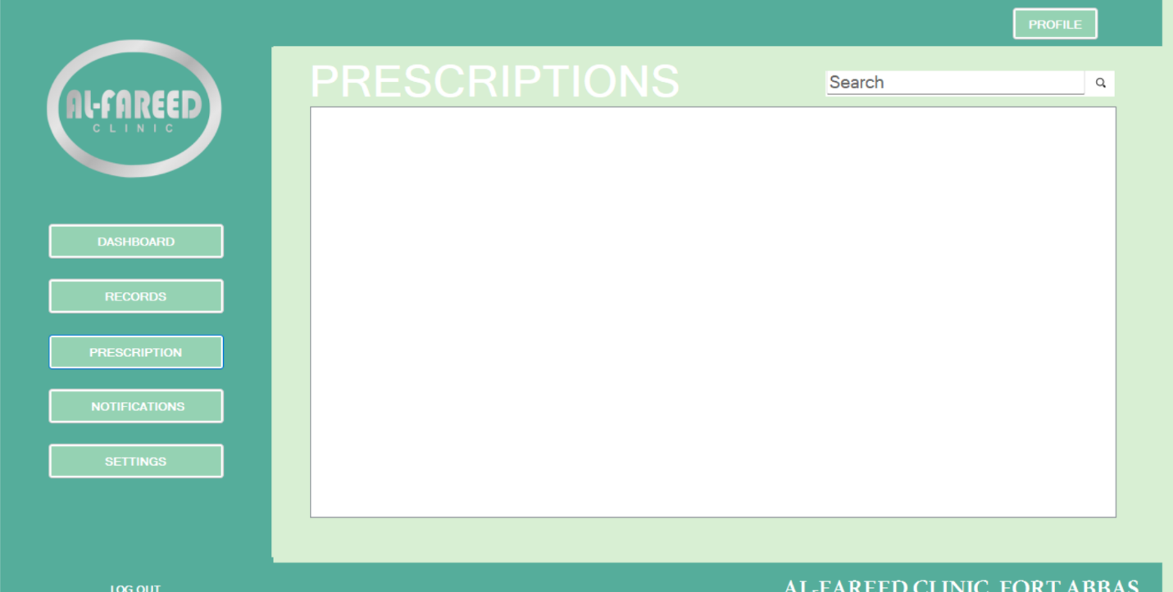

Through this panel doctor would be abel to Edit the Prescription

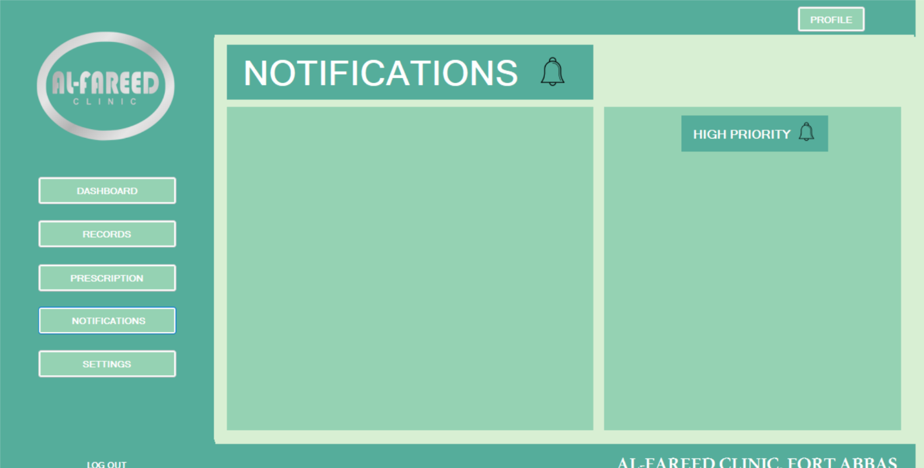

Main Notification Panel to keep users updated 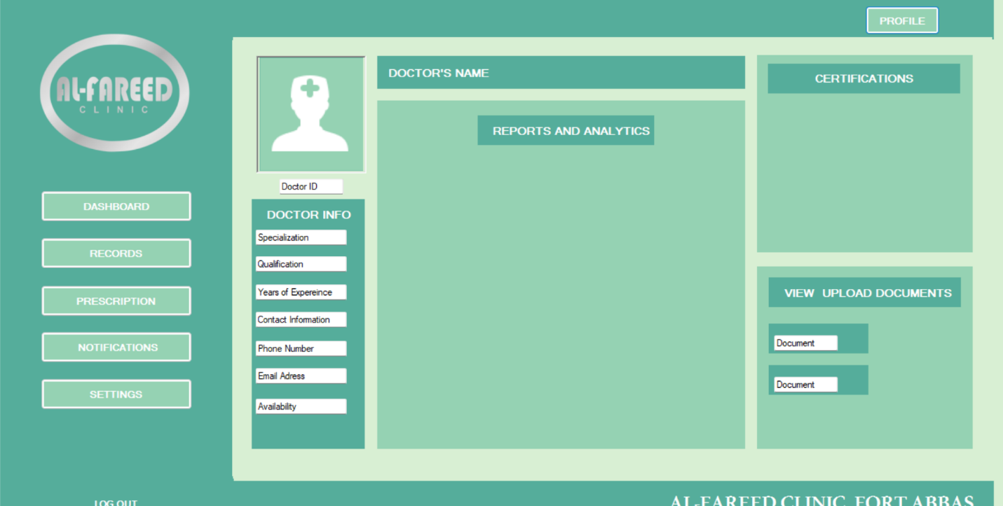

This is Doctor’s Main Profile Same Way we have Patient’s profile as well

### Receptionist:

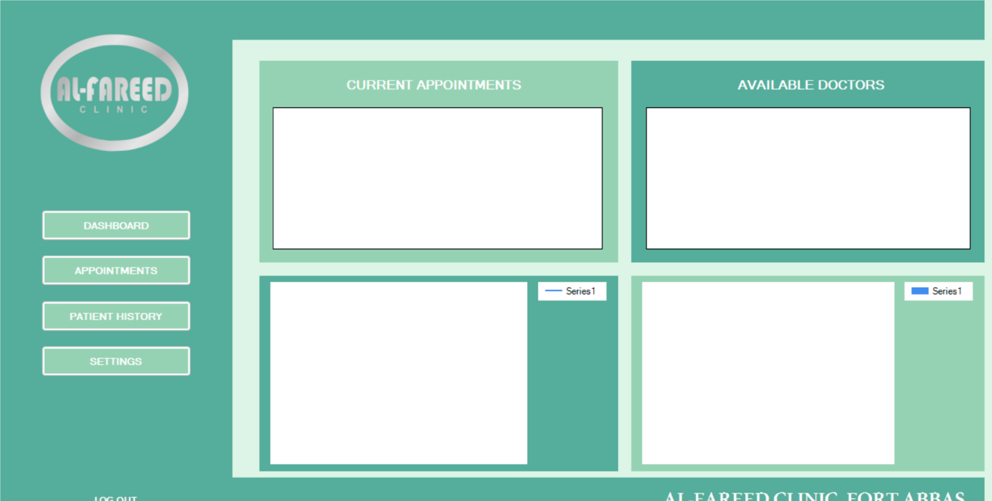Receptionist’s main panel /Receptionist Main Dashboard 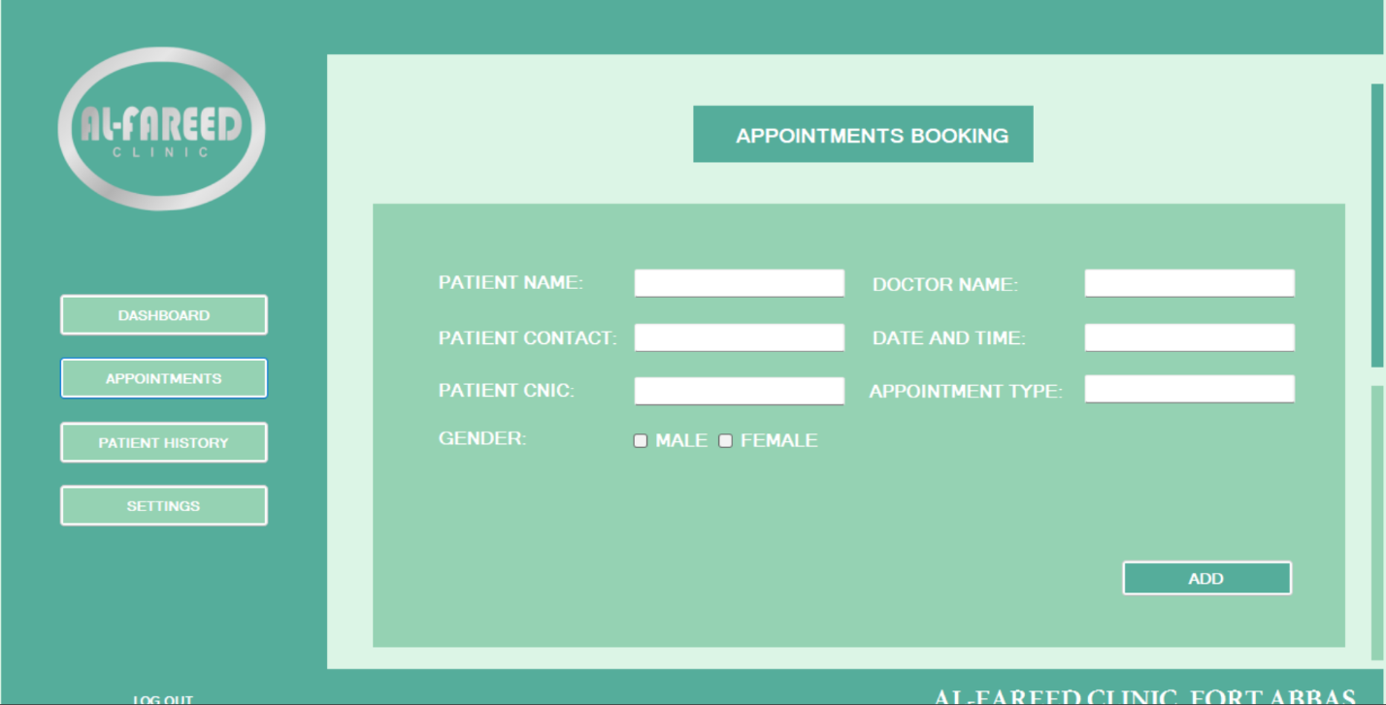

Appointment Booking System from here all of the Appointments would be booked

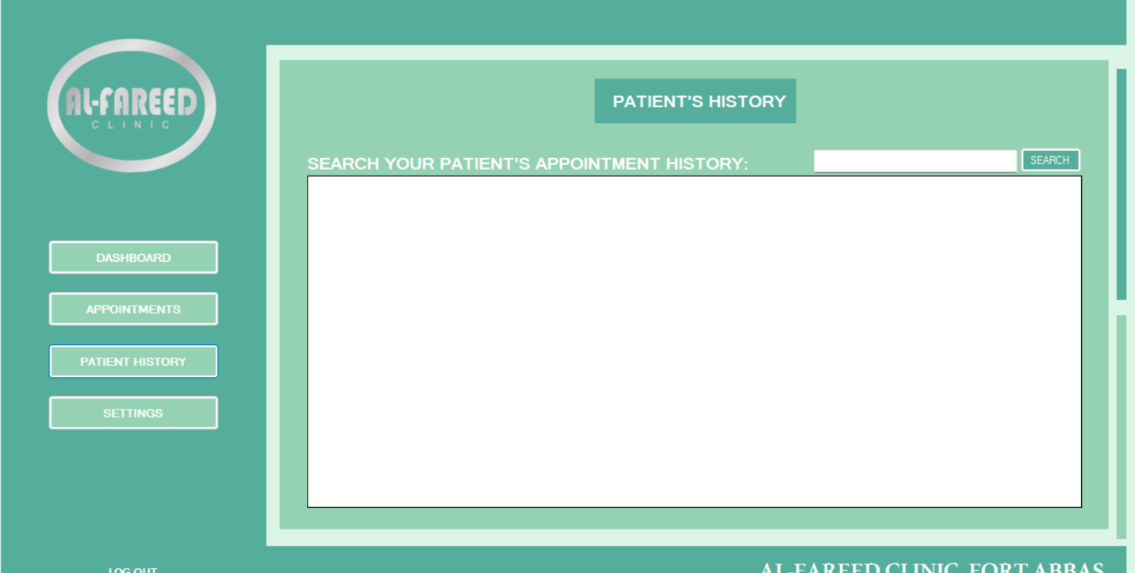

To access Patient’s medical records

# Conclusion

Al-Fareed Clinic's **management system** is an **application** designed to make daily tasks easier for the staff and improve patient care. It helps manage **finances, patient records, pharmacy inventory, appointments, and staff performance** efficiently. By reducing manual work and organizing important data, the system ensures smoother operations and better decision-making. With this system, the clinic can provide **faster, more reliable, and well-managed healthcare services** to the community.

# References

## Diagrams & External Resources Used

[1] Lucidchart. (2025). Lucidchart Diagram. Retrieved from

<https://lucid.app/lucidchart/246e1e12-6b5d-4325-b06d-add05a0f1be9/edit?viewport_loc=-8732%2C-377%2C25142%2C10347%2C0_0&invitationId=inv_683e21e8-4d12-4cee-8dac-5f377d114bd2>

[2] Lucidchart. (2025). Lucidchart Diagram. Retrieved from

[https://lucid.app/lucidchart/82daecb7-804d-4a25-8cd2-f97d6bbb98ed/edit?invitationId=inv_f2bcde5a-4e16-4c3a-a629-2676a8803c69&page=0_0#](https://lucid.app/lucidchart/82daecb7-804d-4a25-8cd2-f97d6bbb98ed/edit?invitationId=inv_f2bcde5a-4e16-4c3a-a629-2676a8803c69&page=0_0%23)

[3] Figma. (2025).Figma Diagram. Retrieved from

<https://www.figma.com/design/w9ES6KtY5DXjlJzLmtfQgd/Untitled?node-id=0-1&p=f&t=RSfXOrVDIBjpellR-0>

[4] dbdiagram.io (2025).db Diagram. Retrieved from

<https://dbdiagram.io/d/67f3ef1f4f7afba184a6b481>

## Bibliography:

*1. Acharya, Kamal, Attendance Management System Project (April 28, 2024).*

*Available at*

*SSRN:* [*https://ssrn.com/abstract=4810251*](https://ssrn.com/abstract=4810251) *or* [*http://dx.doi.org/10.2139/ssrn.4810251*](http://dx.doi.org/10.2139/ssrn.4810251) *2. Acharya, Kamal, Online Food Order System (May 2, 2024). Available at*

*SSRN:* [*https://ssrn.com/abstract=4814732*](https://ssrn.com/abstract=4814732) *or* [*http://dx.doi.org/10.2139/ssrn.4814732*](http://dx.doi.org/10.2139/ssrn.4814732)

*3. Acharya, Kamal, University management system project. (May 1, 2024). Available at SSRN:* [*https://ssrn.com/abstract=4814103*](https://ssrn.com/abstract=4814103) *or* [*http://dx.doi.org/10.2139/ssrn.4814103*](http://dx.doi.org/10.2139/ssrn.4814103) *4. Acharya, Kamal, Online banking management system. (May 1, 2024). Available at*

*SSRN:* [*https://ssrn.com/abstract=4813597*](https://ssrn.com/abstract=4813597) *or* [*http://dx.doi.org/10.2139/ssrn.4813597*](http://dx.doi.org/10.2139/ssrn.4813597)

1. *Acharya, Kamal, Online Job Portal Management System (May 5, 2024). Available at SSRN:* [*https://ssrn.com/abstract=4817534*](https://ssrn.com/abstract=4817534) *or* [*http://dx.doi.org/10.2139/ssrn.4817534*](https://dx.doi.org/10.2139/ssrn.4817534)
2. *Acharya, Kamal, Employee leave management system. (May 7, 2024). Available at SSRN:* [*https://ssrn.com/abstract=4819626*](https://ssrn.com/abstract=4819626) *or* [*http://dx.doi.org/10.2139/ssrn.4819626*](https://dx.doi.org/10.2139/ssrn.4819626)
3. *Acharya, Kamal, Online electricity billing project report. (May 7, 2024). Available at SSRN:* [*https://ssrn.com/abstract=4819630*](https://ssrn.com/abstract=4819630) *or* [*http://dx.doi.org/10.2139/ssrn.4819630*](https://dx.doi.org/10.2139/ssrn.4819630)
4. *Acharya, Kamal, POLICY MANAGEMENT SYSTEM PROJECT REPORT. (December 10,*

*2023). Available at*

*SSRN:* [*https://ssrn.com/abstract=4831694*](https://ssrn.com/abstract=4831694) *or* [*http://dx.doi.org/10.2139/ssrn.4831694*](https://dx.doi.org/10.2139/ssrn.4831694)

1. *Acharya, Kamal, Online job placement system project report. (January 10, 2023). Available at*

*SSRN:* [*https://ssrn.com/abstract=4831638*](https://ssrn.com/abstract=4831638) *or* [*http://dx.doi.org/10.2139/ssrn.4831638*](https://dx.doi.org/10.2139/ssrn.4831638)

1. *Acharya, Kamal, Software testing for project report. (May 16, 2023). Available at*

*SSRN:* [*https://ssrn.com/abstract=4831028*](https://ssrn.com/abstract=4831028) *or* [*http://dx.doi.org/10.2139/ssrn.4831028*](https://dx.doi.org/10.2139/ssrn.4831028)

1. *Acharya, Kamal, ONLINE CRIME REPORTING SYSTEM PROJECT. (August 10, 2022).*

*Available at*

*SSRN:* [*https://ssrn.com/abstract=4831015*](https://ssrn.com/abstract=4831015) *or* [*http://dx.doi.org/10.2139/ssrn.4831015*](https://dx.doi.org/10.2139/ssrn.4831015)

1. *Acharya, Kamal, Burger ordering system project report. (October 10, 2022). Available at SSRN:* [*https://ssrn.com/abstract=4832704*](https://ssrn.com/abstract=4832704) *or* [*http://dx.doi.org/10.2139/ssrn.4832704*](https://dx.doi.org/10.2139/ssrn.4832704)
2. *Acharya, Kamal, Teachers Record Management System Project Report (December 10,*

*2023). Available at*

*SSRN:* [*https://ssrn.com/abstract=4833821*](https://ssrn.com/abstract=4833821) *or* [*http://dx.doi.org/10.2139/ssrn.4833821*](https://dx.doi.org/10.2139/ssrn.4833821)